Final Testing Plan Summary and Test Results

## Team 34: PUCKFish

Team Lead 6: [Alex Necakov](mailto:alexrn@bu.edu)

Will Aracri, Victoria Thomas, Peter Ha, Ammar Hussain

# Contents

**Title Page 1**

**Contents** **2**

**Introduction** **3**

**Testing Plan Overview** **4**

**Test Overview** **5**

Test 1: Water-Proofing and Data Collection 5

Test 2.1: IMU Proof of Concept 5

Test 2.2: Sensor Array Test 6

Test 3.1: Port and Enclosure Testing 6

Test 3.2: Full Hardware Test 6

Test 4: Full PUCKFish Test 6

**Test 1.0** **7**

**Introduction and Overview** **7**

**Summary of Procedure and Required Equipment** **7**

**Results** **9**

Conclusion 10

Testing Plan

# Introduction

PUCKFish is a device containing sensors (Temperature, Dissolved Oxygen, Salinity, Current Velocity, Depth, Ambient Light) to be mounted on top of lobster traps in order to monitor the best possible locations to place traps for maximum catch yield. In order to function, the device must operate under water at depths of up to 1100 feet and then transmit data wirelessly to a base station upon retrieval.

In order to properly test PUCKFish to determine its effectiveness as well as aid in the design interaction process, the team considered the major challenges of the project and then broke them down into testable conditions. These attributes are as listed below.

Major Challenges and Required Testing Capabilities include:

1. Sensor Arrays and Related Electronics: All sensors (accelerometer, light sensor, temperature sensor, orientation sensor, and radio transmitter) must be tested with related electronic elements to ensure the required accuracy and precision metrics are achieved
2. Device Body durability: Ensure that the skeleton of PUCKfish can be properly cast in epoxy within a 3D printed or silicone mold

By considering the major challenges above, a testing plan as well as a general technical development plan could be developed and executed.

# Testing Plan Overview

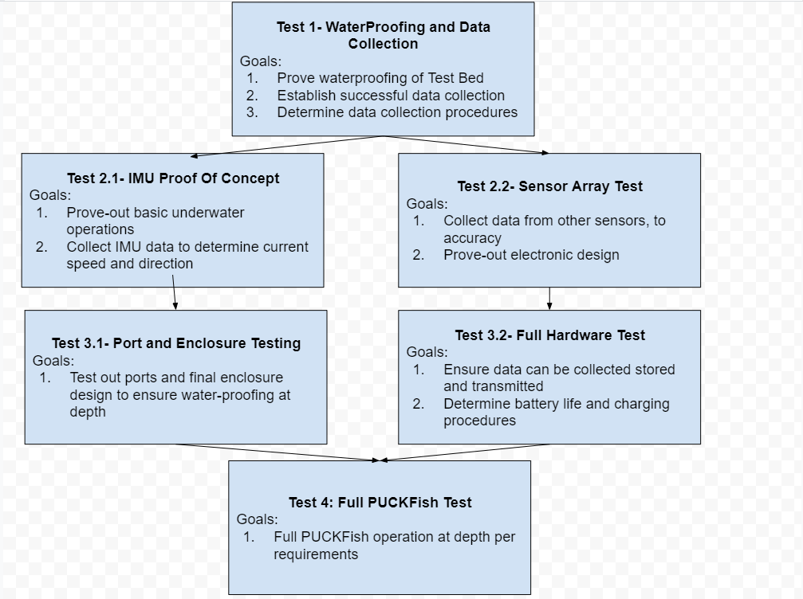

*Figure 1: Testing Plan*

The overall testing plan involves 6 separate tests with goals that build upon each other to achieve the end result of a final operational test with PUCKFish. Included in the testing plan were requirements for the team’s structure as to eliminate blockers and keep work progressing.

The plan involves an initial step proving how the team can come together to perform a successful test. It then moved into two parallel paths that developed the electronic systems and mechanical systems in tandem. By creating parallel paths, the team believes that PUCKFish can be developed in a shorter amount of time while continuously proving out technologies required for the next stage. These small proof of concepts allow for minimal risk in carrying out electronic tests in the water as to limit the possibilities of hardware damage or failures.

Additionally, the goals of each test will be refined as data is collected from tests earlier in the testing plan, allowing for more targeted objectives and quantifiable testing requirements. Specific procedures for each test will be developed based upon knowledge gained from previous tests. This will allow more streamlined testing as well as refining the actual test environment to achieve the required metrics.

# Test Overview

Each test with their accompanying goals is outlined below. Where applicable, if a test requires data or knowledge from a test prior in the testing plan, a description is provided with how these requirements will be developed.

## Test 1: Water-Proofing and Data Collection

The major goals of Test 1 are as follows.

1. Prove waterproofing of Test Bed
   1. The test bed of the PUCKFish is a waterproof enclosure designed to test systems under-water without development time of producing a final enclosure design. This additionally demonstrates how the mechanical engineering subteam can design an enclosure to withstand low-depth submersion in water.
2. Establish successful data collection
   1. Establishing data collection is essential to determine how to transmit data to the base station. In addition, data collection remotely will be of use in later tests where depth is lower and adjustments to the testing environment can be made on the fly without removing the electronics and checking the hardware itself.
3. Determine Data Collection Procedures
   1. By determining data collection procedures, the team can share a common resource that does not require explanation or full team attendance to successfully run a test. This provides faster data collection and more refined technical developments in future tests.

## Test 2.1: IMU Proof of Concept

The major goals of Test 2.1 are as follows

1. Prove-Out basic underwater operations
   1. The IMU test bed will take place in a body of water with some current velocity and at a more significant water depth. This experience will allow the team to better understand how to operate and contend with running tests underwater which will be paramount for further development.
2. Collect IMU Data to determine current speed and direction
   1. After developing a model for how to produce an orientation from IMU data, the team can create models based upon flow around the PUCKFish to determine current speed and velocities. Proving these models work is paramount to the final success of PUCKFish.

## 

## Test 2.2: Sensor Array Test

The major goals of test 2.2 are as follows

1. Collect data from other sensors to accuracy
   1. Collecting the data from the sensors, excluding the IMU, will allow the team to determine how to get data form the sensors and if the sensors achieve the necessary grades of precision and accuracy.
2. Prove-out electronic design
   1. In order to collect data from the sensors, there must be something to read and translate the data to be read. This hardware setup will allow the team to gain experience with building out the necessary electronic set up as well as proving out technology in design.

## Test 3.1: Port and Enclosure Testing

The major goals for test 3.1 are as follows

1. Test out ports and final enclosure design to ensure water-proofing at depth
   1. Using experience from tests 1.1 and 2.1, test 3.1 allows for testing the enclosure at depth without electronics to determine waterproofing. In addition, somes sensors require exposure to the water surrounding the enclosure, to do this PUCKFish uses ports to the outside. It is important to determine that ports can do this successfully without letting water into the enclosure.
   2. Prove effectiveness of final silicone mold and the parts it casts

## Test 3.2: Full Hardware Test

The major goals for Test 3.2 are as follows

1. Ensure data can be collected stored and transmitted
   1. The final PUCKFish must be able to store and transmit full data sets. Prior tests do not require this capability, so it must be proved here.
2. Determine Battery Life and Charging procedures
   1. Prior tests do not require the battery life and charging to accomplish them. In order to prove the batteries capabilities, this will be proven here.

## Test 4: Full PUCKFish Test

The major goals for Test 4 are as follows

1. Full Operation at Depth
   1. This test is the final test for PUCKFish. It includes all of the prior test’s requirements and should reach full operation or the path to full operation.

After determining the testing plan and each test and their goals, the team was prepared to run Test 1: WaterProofing and Data Collection

# Test 4: Full PUCKfish Testing

# Introduction and Overview

The goals for this test are as follows:

1. Prototype precisely reports acceleration data
2. Prototype precisely reports light data
3. Prototype precisely reports temperature data
4. Prototype precisely reports orientation data
5. Prototype precisely reports dissolved oxygen data
6. LoRa receiver accurately receives data
7. Unit remains waterproofed and functional in water

# Results

From the electronics point of view, the test can be viewed as a success. The prototype was able to collect acceleration, orientation, temperature and light data while encased in epoxy and in a bucket of water. The prototype was able to transmit the data that it stored on its SD card storage unit, to the LoRa receiver, which was successfully receiving the data as well. Similar to the previous test, the unit was shifted to different orientations to demonstrate the acceleration and gyroscope working as intended. A dark object was placed over the light sensor to demonstrate it responding to a change in ambient light. All of these data were collected and output in JSON format through a serial monitor.

The epoxy enclosed prototype was also able to be successfully recharged using the Qi standard wireless charging setup. Unfortunately prior to the test, the dissolved oxygen, salinity, and pressure sensors were having trouble collecting data, so no data was received from those sensors in the under-water test.

# 

# Summary of Procedure and Required Equipment

| **OP 1: SETUP** |  |
| --- | --- |
| Op | Description |
| 1.1 | Connect LoRa receiver to laptop |
| 1.2 | Place PUCKfish on wireless charging pad |
| **OP 2: TESTING PROCEDURE** |  |
|  | Description |
| 2.1 | Remove PUCKFish prototype from charging pad |
| 2.2 | Place PUCKFish unit within body of water |
| 2.3 | Confirm integrity of PUCKFish unit under water |
| 2.4 | Move the device, confirm that the accelerometer is accurately reporting data |
| 2.5 | Change the orientation of the sensor, confirm that the orientation sensor is accurately reporting data |
| 2.6 | Cover and uncover the light sensor, confirm that the accelerometer is accurately reporting data |
| 2.7 | Remove PUCKFish unit from water |
| 2.8 | Confirm the LoRa receiver is receiving data |
| 2.9 | Monitor transmission from PUCKFish over LoRa |
| 2.10 | Confirm the sensors responded to stimulation as expected (temperature and dissolved oxygen will change merely by being in/out of water) |
| 2.11 | Assess waterproofing effectiveness by seeing if unit still functions, and has not absorbed water |
| **OP 5: DATA COLLECTION AND ANALYSIS** |  |
| OP | DESCRIPTION |
| 5 | export data to a text file |
| 5.1 | Separate Data via the timestamps collected in ops 2.1-2.11 |
| 5.2 | Gather Averages of the data given in "TEST4, DATA ANALYSIS" in this google sheet |

*Table 1: Procedure as Outlined*

After the procedure had been written the test could be run. However, after realizing that water could not be procured in the Senior Design lab during the test, the team decided to omit the underwater active portion of this test. Instead, this portion was performed after the data collection with success. In addition, by reviewing the data, it was determined that only a couple sample seconds from the test would be required, not orientation, to determine the path forward

The equipment requirements of the test can be seen below in *table 2*. This equipment as only listed for the active data collection portion of the lab as the other portions wrapped into the test were completed prior to the display in the senior design lab.

| **REQUIRED MATERIALS** |  |  |
| --- | --- | --- |
| Item | Name | Quantity |
| 1 | PUCKfish prototype unit | 1 |
| 2 | LoRa receiver | 1 |
| 3 | Qi Wireless Charging pad | 1 |
| 4 | Laptop | 1 |
| 5 | Cables | 1 |

*Table 2: Materials List*

# 

# Results

During the test, the IMU and Light Sensor were placed onto the PCB with the microcontroller. The PCB was shifted to different orientations to demonstrate the acceleration and gyroscope working as intended. A warm object was placed on the temperature sensor to show the response of the temperature sensor. A dark object was placed over the light sensor to demonstrate it responding to a change in ambient light. All of these data were collected and output in JSON format through a serial monitor. This data was received by a radio receiver and also output through a serial monitor to verify fidelity of transmission. Below is the serial monitor output from the microcontroller directly connected to the sensors.

{

"timeStamp": 311107,

"acceleration": [

2.657563925,

0.646434486,

-10.83855152

],

"orientation": [

-0.029977029,

-0.026113322,

-0.043166921

],

"temperature": 27.07117653,

"ambientLight": 37.5

}

{

"timeStamp": 326173,

"acceleration": [

2.681505919,

0.627280831,

-10.84812832

],

"orientation": [

-0.027179174,

-0.026513018,

-0.044366002

],

"temperature": 27.11823463,

"ambientLight": 31.66666603

}

{

"timeStamp": 341666,

"acceleration": [

2.650381327,

0.648828685,

-10.80982113

],

"orientation": [

-0.024914242,

-0.022782542,

-0.043033689

],

"temperature": 27.07117653,

"ambientLight": 34.16666412

}

{

"timeStamp": 357585,

"acceleration": [

2.588132143,

0.588973641,

-10.76433086

],

"orientation": [

-0.027312404,

-0.025313934,

-0.044765696

],

"temperature": 27.35352898,

"ambientLight": 32.5

}

{

"timeStamp": 373927,

"acceleration": [

2.695871115,

0.617704034,

-10.83136845

],

"orientation": [

-0.026379786,

-0.027578866,

-0.041701376

],

"temperature": 27.21235275,

"ambientLight": 32.5

}

*Table 3: Test Results*

## Conclusion

Through reviewing the acceleration data, the format and data collection methods were determined as a success. By testing the enclosure in the bathtub, the water proofing portion of the test was also successful. Despite running into minor issues in setting the epoxy, we have concluded that the waterproofing of the device is a success. Additionally, though we ran into issues with the dissolved oxygen sensor, all other sensors worked as expected. In conclusion, our device worked as expected and we will be able to learn from our mistakes on our next iteration.